Let’s watch a quick video to get inspired!

https://www.youtube.com/watch?v=pPnGvjmIgZA

An Electric Science Fair!

Your project for this unit will be a self (or partner)- directed project. You will look over the curriculum checklist and decide on a topic you want to study.

After considering the type of project students did last year, you can see that, although that is one option, there are many different areas to choose from. And MANY different ways to showcase your work!

Please consider the following that you will need to review in a brief interview with Ms. Booth/Mr. Vankleeck before moving forward. Please respond to these questions either in a google doc and share it with us, or in hard copy and have it ready for your ‘interview’.

- what type of media/technology will your project include- a prototype/model, an advertisement/video, a short play or talk show, a trifold, an infographic (see Piktochart or example in the classroom)… or any other ideas you have!

- what are at least 3 resources you will use to gather information- if they are websites or links to videos, please indicate them)

- how will you ensure that, when considering the rubrics for stems 3 and 4, you will record and educate people on all the necessary information about your topic?

- what materials/supplies do you need? Is it feasible to get these supplies or do you need to modify your plan?

Please look at the rubric below to understand the assessment expectations. You also saw examples of some projects from last year as a form of reference.

Rubric- ‘An Electric Science Fair’

Stem 2- first two rows Stem 3- last two rows
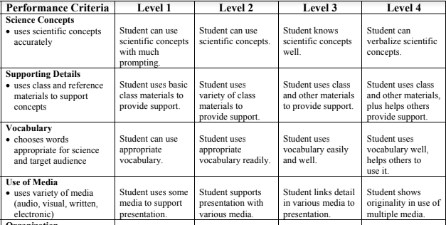

Stem 4
