Science 9

Environmental Chemistry

Chemicals in the Environment

Curriculum Connection

- Identify chemical factors in an environment that might affect the health and distribution of living things in that environment

- Describe effects of acids and bases on living things
- Interpreting LD50 data and other information on toxicity

Background Information

- The total amount of taken in by an organism is called a dose, and the effect a chemical has on a living organism is called the response. The effect a chemical has on a living organism is related to its dose and the remaining concentration of chemical in the organism.

- Toxicity tests enable toxicologists to learn about responses of living organisms to doses of chemicals.

- The measure of dose in toxicology is important; a large dose of a beneficial chemical can have a harmful effect, and a small dose of a harmful chemical can have no adverse effect. In the words of the 16th-century physician

Paracelsus, “All substances are poisons; there is none which is not a poison. The right dose differentiates a poison from a remedy.”

Question

- What is the effect of common household chemicals on the germination rate of ____ seeds?

Materials

- 6 resealable plastic sandwich bags
- 12 paper napkins

- 6 beakers of chemical solution, ranging from 0% to 100% concentration
- 1 bag of seeds (approximately 60 seeds in a bag)
- 1 permanent marker

- latex gloves
- safety glasses

Hypothesis

- Complete a hypothesis statement that addresses the question, using and “If…then…” format

Procedure

- Label all six bags with your team members’ initials and a number and a percent concentration of chemical, like this:

  - #1 0% (control)
  - #2 10%
  - #3 20%
  - #4 30%
  - #5 50%
  - #6 100%

- Put two napkins together and fold them in half so that they fit into the plastic bag. Fill each bag with two folded paper napkins.
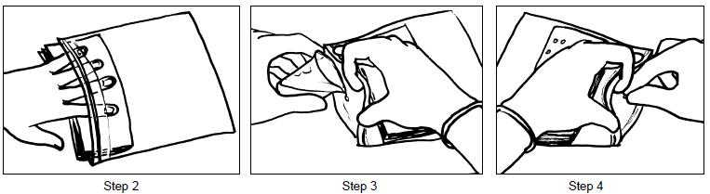
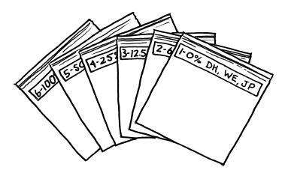

- Put on the safety glasses and latex gloves. Carefully pour the chemical solutions into the bags, making sure to match the numbers and concentration percentages of the bag and the chemical. Each bag now will contain 20 mL of chemical solution that is absorbed by the paper napkins.

- Count out 10 seeds. Carefully place the seeds on the moist paper napkins in the control bag (#1), making sure to space them evenly (do not clump them in one spot). Seal the plastic bag, pushing out the air as you go.

- Repeat Step 4 for the remaining bags.

- Observe the seeds and fill in the data table with information you know at this time.

- Place the seed bags in a stack, lying flat with the seeds up, on the tray. Put the tray of seeds on the lab bench at the back of the room.

Observations

Bag %

- Concentration

 |  |  |  |  |  |  |  |  | Response
 |  |  | Day 1 |  |  |  |  |  | Day 2 |  |  |  |  |  |  |  | Day 3
 |  |  | # seeds |  | # seeds not |  |  |  | # seeds |  |  |  | # seeds not |  |  |  | # seeds |  |  |  | # seeds not
 |  |  | germinated |  | germinated |  |  |  | germinated |  |  |  | germinated |  |  |  | germinated |  |  |  | germinated

- 0

- 10

- 20

- 30

- 50

- 100

Analysis

- Construct a graph to represent your data. Be sure to include the following: o x axis label

o y axis label o title

o legend (if necessary)

o reasonable scale (consistent, takes up minimum half the page) o LD50 point (if possible)

Conclusion

- Identify the manipulated variable in this experiment.

- Identify the responding variable in this experiment.

- What is the trend you observed in your graph?

- What was your chemical? How does this chemical have an impact on human life? Do you consider this chemical harmful, beneficial, or neither?

- Explain how this chemical might get into the environment.

- Compare your results to two other groups in the class. How does your data differ from theirs? Be specific and explain why this might be.

