Environmental Chemistry:
Unit Final

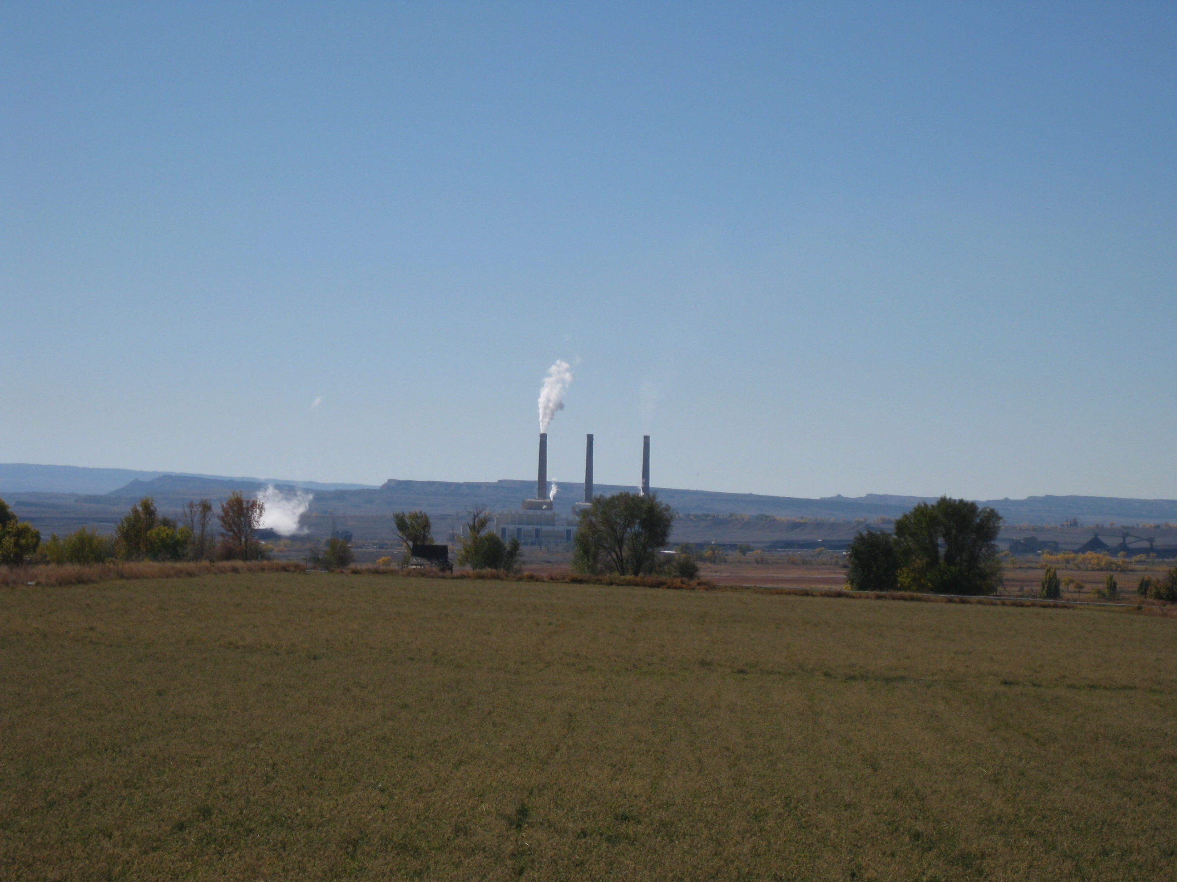
COAL FIRED POWER PLANT IN UTAH RIVERWATCH RAFT

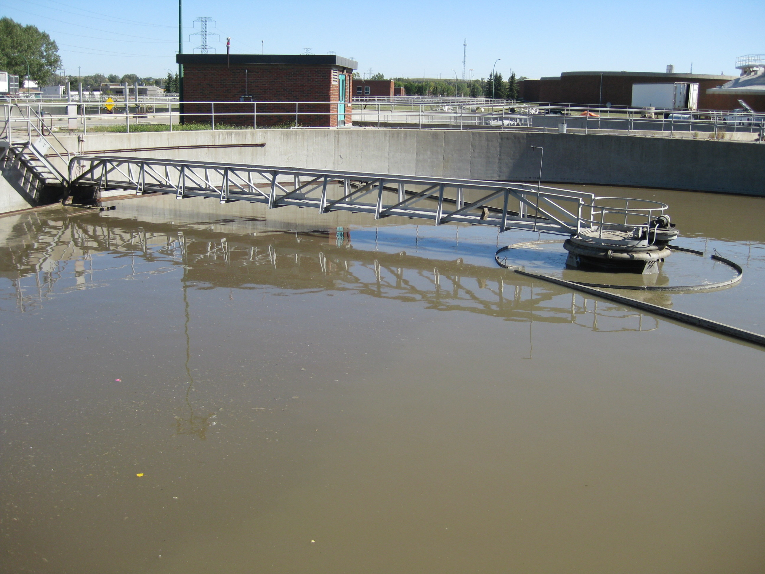
BONNYBROOK SEWAGE TREATMENT PLANT

- Do not write in this bookleT!
- Please read each question carefully.
- Select the answer that best matches the statement.
- GOOD LUCK!
1. The nitrogen in the air has to be released in a form that can be combined with other compounds. The release of nitrogen from nitrogen gas is called
a. nitrogen fixation and involves bacteria
b. a cycle and involves bacteria
c. nitrogen fixation and involves the Sun
d. a cycle and involves the Sun

2. The population of peregrine falcons has declined because of the use of DDT. This chemical is considered a _______ and was frequently used in the 1970s to control harmful ________
a. herbicide, weeds
b. pesticide, insects
c. fungicide, fungus
d. bactericide, bacteria

3. Over the past 15 years, a farmer kept careful crop production records. He noticed that the crop yield increased when he used an insecticide (a type of pesticide) for controlling the grasshopper problem, but only for the first 10 years. The insecticide did not seem to work after that. The most probable reason that the farmer needed to use a higher concentration of insecticide after the 10 year period is that the insects
a. that survived the previous applications passed their resistance to that concentration on to their offspring
b. were not affected by the insecticide because it was absorbed into the soil
c. reproduced more quickly to replace those killed by the insecticide
d. increased in size and weight and became more tolerant of the insecticide

4. You neighbour Saad adds a nitrogen-rich (lots of nitrogen) fish fertilizer to make a thick dark green lawn. Which bag of fertilizer did your neighbour use?
a. 11-55-0
b. 0-52-12
c. 34-5-5
d. 0-0-60

5. The pie graph shows the approximate distribution of essential gases that make up the composition of air.

Which essential gas found in air is represented by sector A?
a. oxygen
b. carbon dioxide
c. nitrogen
d. hydrogen


6. By measuring the pH of several chemical substances, the student is actually measuring the concentration of ____ ions in the solution.
a. oxygen
b. hydrogen
c. nitrogen
d. carbon

7. Milk has a pH of 6. A particular brand of toothpaste has a pH of 8. How many times more acidic is milk when compared to the toothpaste?
a. 2
b. 8
c. 10
d. 100

8. A pH test done on normal rain water indicates a pH reading of 5.6. This reading is slightly acidic because
a. rain water combines with carbon dioxide to produce carbonic acid
b. rain water is always acidic
c. rain water combines with mercury vapor to produce acid rain
d. rain water combines with salt to produce a salt solution

9. Ashleen tested several solutions with litmus paper. Because one solution was basic, she found that blue litmus paper
a. changed to red
b. changed to green
c. remained blue
d. changed to yellow

10. All organic compounds have the element ____ in their structure.
a. hydrogen
b. oxygen
c. carbon
d. nitrogen

11. Oils belong to a group of organic compounds called
a. carbohydrates
b. starches
c. lipids
d. proteins

12. Plant nutrients such as nitrogen, phosphorus and potassium are considered:
a. macronutrients
b. micronutrients
c. meganutrients
d. non essential nutrients

13. Hydrolysis is a process that occurs during digestion. The word "hydrolysis" is derived from the words "hydro" and "lysis." What do these words mean?
a. "hydro" means hydrogen and "lysis" means to combine
b. "hydro" means water and "lysis" means to break down
c. "hydro" means water and "lysis" means to combine
d. "hydro" means hydrogen and "lysis" means to break down

14. A large starch molecule is hydrolyzed into maltose and ends up in a simple usable form called
a. amino acid
b. fatty acid
c. vitamins
d. glucose

15. Diagram A changes into diagram B through the process of
a. capillary action
b. diffusion
c. active transport
d. osmosis
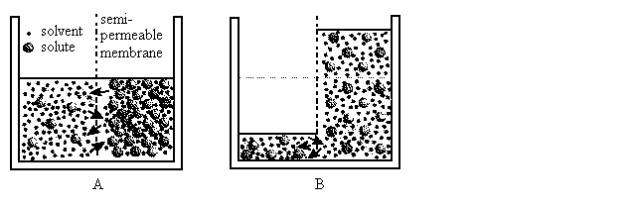
16. Sarin, a toxic nerve gas, becomes a serious problem at a dose of 24 mg/kg. This toxicity is measured using the symbol
a. AB50
b. XY50
c. LD50
d. TP50

17. Acid shock occurs when high concentrations of acidic water affect the lake organisms. What season of the year does this usually happen in?
a. winter
b. summer
c. fall
d. spring

18. Gurpreet mixes 0.01 mL of food colouring into 1 L of water during a science lab. Calculate the concentration of food colouring in ppm.
a. 100 ppm
b. 0.6 ppm
c. 10 ppm
d. 1 ppm

19. The graph illustrates how the dissolved oxygen content in Rapid River is affected by sewage effluent from a treatment plant.

What is the oxygen content in Rapid River 25 km from the treatment plant?
a. 2 mg/L
b. 4 mg/L
c. 6 mg/L
d. 8 mg/L
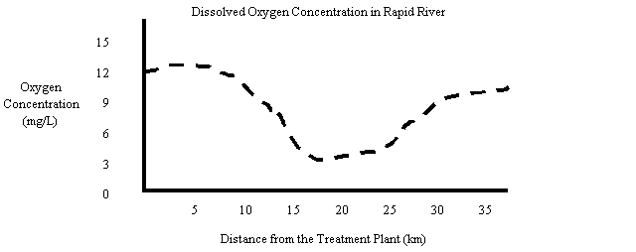

20. In science class, you learned that air is actually a mixture of several different gases. The two main gases that make up our air are
a. carbon and oxygen
b. carbon dioxide and nitrogen
c. carbon dioxide and oxygen
d. nitrogen and oxygen

21. Carbon monoxide is a deadly gas that reduces the amount of oxygen carried by the blood. The correct chemical formula for carbon monoxide is
a. CO
b. CO2
c. C2O
d. C2O2

22. Ozone is a gas that is helpful when it is located high up in Earth's atmosphere, but acts as a harmful pollutant at ground level. The chemical formula for ozone gas is
a. O
b. O2
c. O3
d. O4

23. Three of the major air pollutants found in large urban areas include nitrogen oxides, carbon monoxide, and ground-level ozone. The main cause of these pollutants in large urban areas is
a. the production of large volumes of household waste
b. the combustion of fuel in gasoline-powered vehicles
c. the burning of oils and gases in industrial processes
d. the large population of people breathing the air

24. Water vapour, carbon dioxide, methane, and nitrogen are all found in Earth's atmosphere. These substances all help to trap heat inside Earth's atmosphere. Collectively, these substances are known as
a. biological inhibitors
b. chemical pollutants
c. greenhouse gases
d. toxic wastes

25. There is a naturally formed layer of ozone gas 15 to 50 km above Earth's surface. This layer of gas provides important protection from a dangerous form of radiation that comes from the Sun. This form of radiation is associated with human skin cancer, cataracts, and the destruction of plankton. This form of energy is known as
a. infrared radiation
b. gamma radiation
c. ultraviolet radiation
d. x-ray radiation

26. A fertilizer plant located 75 km from Red Deer, Alberta, releases sulfur dioxide into the atmosphere. On windy days, the concentration of sulfur dioxide in Red Deer's air increases. It is believed that this increase is directly related to emissions at the fertilizer plant being blown by the wind to Red Deer. This spreading of pollutants from their source is called
a. decomposition
b. deposition
c. dispensation
d. dispersion

27. A new landfill site is being constructed in your city. The project engineer must decide what material he will use at the bottom of the site to prevent pollutants from seeping into the groundwater below. Which natural material would best serve this purpose?
a. clay
b. sand
c. gravel
d. rocks and boulders

28. As water moves through the ground, it reaches a zone where all the spaces between soil particles are filled with water. This zone is called the
a. aqueduct zone
b. groundwater zone
c. permeable zone
d. water table zone

29. A local lake's water quality was tested recently and was found to contain high numbers of protozoans. Protozoans are microscopic organisms that indicate the presence of organic pollutants in the water. Which of the following is the most likely source of this pollutant?
a. a landfill site near the lake
b. a busy highway near the lake
c. a large cattle operation near the lake
d. a fertilizer plant near the lake

30. A few weeks after farmer Harkirat spreads fertilizer on his fields, he notices that the algae in his pond are growing out of control. When he talks to an agriculturist, he learns that the most likely reason for this algal bloom is that the fertilizer he put on his fields has been dissolved by water that has passed through the soil and drained into the pond. As a result, the algae have benefited from this fertilizer. What is the term used for the liquid that has passed through the soil, dissolved the fertilizer, and carried it to the pond?
a. groundwater
b. leachate
c. residue
d. filtrate

31. Hydrocarbons are compounds that have only hydrogen and carbon atoms. These hydrocarbons are used in both vehicles and industry. Some of these hydrocarbons do not dissolve in water. Instead, they coat soil particles and tend to build up in high concentrations. Hydrocarbons that are unable to dissolve in water are said to be
a. soluble in water
b. insoluble in water
c. diluted in water
d. concentrated in water

32. Nadia’s lawn maintenance company uses a premixed liquid solution to apply fertilizer to lawns. To make the solution, water is mixed with concentrated granular fertilizer. By using the correct amount of water, the fertilizer will be applied to lawns at the appropriate concentration. What is the term that describes the process of reducing the concentration of a substance by adding water?
a. dilution
b. disintegration
c. dispersion
d. dissolving

33. A new technology for making plastic bags involves using materials that will decompose when exposed to sunlight. After about three months, the reactions have changed the plastic bag into a fine powder. This process of decomposing materials by exposure to light is known as
a. photolysis
b. photodecomposition
c. photoreduction
d. phytoremediation

34. Some lakes in Alberta contain mercury that can come from natural sources or pollution. People who catch and eat fish from these lakes are advised to not consume more than one meal per week of these fish. Why is this advice given?
a. Fish in these lakes absorb mercury from the foods they eat and pass it on to humans.
b. Fish in these lakes are unhealthy due to the mercury and likely carry disease.
c. Fish in these lakes are limited and must be protected from over-harvesting.
d. Fish in these lakes often have physical deformities due to the mercury.

35. A field is sprayed with herbicide to kill weeds. Mice living in the field eat the sprayed plants and, as a result, have the herbicide present in their bodies as a pollutant. An owl feeds on ten of the mice living in the field and therefore ingests the pollutants present in all ten mice resulting in an increase in the pollutant's concentration. This is an example of
a. biomagnification
b. biodestruction
c. biodegradation
d. biohazard

NUMERIC RESPONSE SECTION

1. Calculate the ppm if 7mL of mercury is put into a lake that contains 700 000L of water.

2. What is the difference in strength of two solutions, one having a pH of 7.0 and the other a pH of 9.0 ?

3. Using the water quality data below, rank the lakes in order from most healthy to least healthy:

 | 1) Lake Mang | 2) Lake Wilson | 3) Lake Potorti | 4) Lake Barbor
pH | 6.5 | 7.5 | 7.4 | 6.9
Dissolved O2 | 6.5 | 7.0 | 7.3 | 7.1
Phosphorous | High | Medium | medium | low

___________ _________ __________ _________
Most healthy less healthy even less healthy least healthy

4. How many millilitres are in one litre?

5. Ms. Wilson decides to make a stew for the class party. She adds 1 mL of powdered bat wings to her 50L mystery meat stew. How many ppm of powdered bat wings are in her stew?

Page 1

1. a
2. b
3. a
4. c
5. c
6. b
7. d
8. a
9. c
10. c
11. c
12. a
13. b
14. d
15. d
16. c
17. d
18. c
19. b
20. d
21. a
22. c
23. b
24. c
25. c
26. d
27. a
28. b
29. c
30. b
31. b
32. a
33. a
34. a
35. a

